Minutes of the Annual General Meeting held

DATE: Wednesday the 10th of August 2021
TIME: 6:00 pm
VENUE: Development House, 76 Esplanade, Darwin NT
CHAIR: Tony Hillier

Meeting Opened at 6:17pm

Welcome and Apologies

President Tony Hillier welcomed all present and accepted apologies as per below table.
Member Organisation | Attendee Name | Apologies Name
Earthbuilt P/L | Tony & Jennifer Hillier
Halkitis Bros | Nick & Helen Halkitis
Constructability NT |  | Brad Pearce
AKSC |  | Mitch King
KSI Land & Water Planning | Ian Lancaster
JN Mousellis Civil Contractors | Peter Mousellis
Ostojic | Geoff Hill
Aldebaran Quarries | Bill Skews
Aldebaran Contracting | Jacob Skews
Clayton Utz | Simon Fosterling
Connect Environmental |  | Mihkel Proos
Remote Industries Aust | Jared Baldwin
Sage Contracting | Sam Sage
EcOz |  | Ray Hall
Castaway Exploration |  | Sharon Wilson
Komatsu | Damien Loller & Zeke Szmekura
Territory Sands | Nigel Doyle
SLR Consulting |  | Paul Turyn

Attendance & Apologies

Minutes of the previous AGM held 9th September 2020

A motion to accept the previous AGM’s minutes was:
Moved: Bill Skews.
Seconded: Nick Halkitis and approved unanimously.

Presidents Report 2020 – 2021 – Tony Hillier

It is my privilege to have been, President of the Extractive Industries Association of NT (EIA) since April 2019 and to now Chair this our annual meeting and present my third report as President.

EIA has made further progress this last twelve months towards realizing its goal of “Being the voice of its Members to all Stakeholders, towards a more balanced and efficient operating environment.”

To achieve this goal, we have a strategy of providing representation to all levels of government, reviewing relevant legislation, regulation and submitting suggestions that improve our operating environment, as well as providing forums for our members and their guests to learn at and from time to time simply socialise with colleagues.

I’d like to take this opportunity to outline our accomplishments on your behalf. Firstly, we divide our efforts particularly or CEO along the following lines.

Now to achievements over the last year or three.

Membership. Over the past three years, Membership has stabilised and is now increasing. The increase in Associate Memberships shows interest in being associated with the sector.

Membership revenue is almost back to highest ever level.

Corporate. Over the last three years we have stabilized revenue and expenses as our Treasurer will point out in more detail shortly.

During this same period, we have become compliant with the ATO, Attorney General’s Department, Insurance requirements and re- secured long-term low-cost office accommodation.

Influencing.

CEO relationships established with all levels of government, in readiness for adverse event management.
Reduced the size of Mining Management Plans by approximately half.
Completed the Code of Conduct.
Established a website, Linked in and Facebook presence.
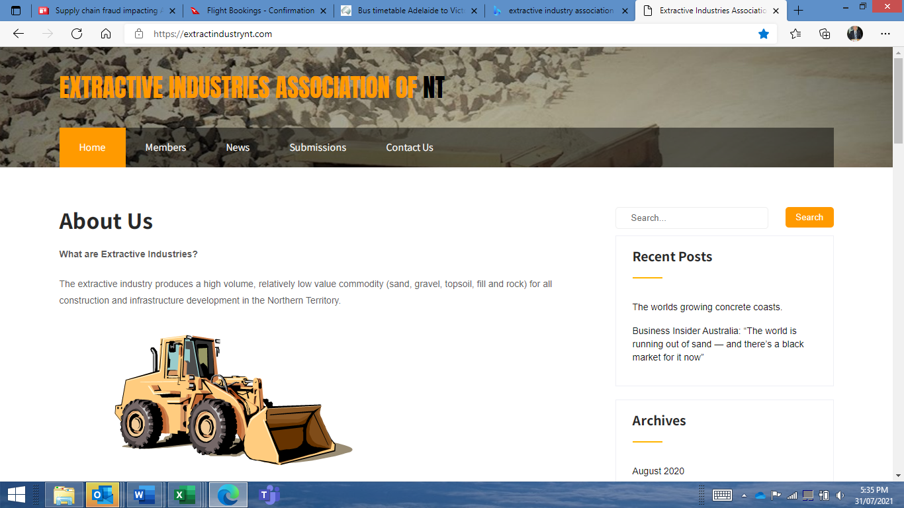

Argued against the Environmental Legislation & Regulation, this challenge is ongoing.
Argued against Extractives being included in the Mining Remediation Fund, this challenge is ongoing. Recently another window of opportunity to influence this in our favour has opened.
Argued for the same Rehabilitation Requirements for Mining Lease holders and Borrow Pit users, this challenge is ongoing.
Argued that Mining Leases that are no longer useable due to changes outside the lease holder’s control e.g., recently declared threatened species should be compensated, this challenge is ongoing.
Rebound Task Force Submission, gained us recognition of the essential nature of our products and service.
Gamba Grass Submission argued it was a community wide issue and should be addressed by a broad community wide approach, Gamba Army established.
Roads Of Strategic Importance (ROSI), argue NT based business had the capacity to deliver this programme.
Lockdown review argued a disproportionate response and we should be treated as an essential service.
Seabed Mining Ban Submission argued no different to terrestrial mining in terms of need for knowledge, legislation, and regulation to appropriately harvest this resource. It appears we have lost this one for the foreseeable future.

Going Forward.

Lobby to minimize impact of shift of Mining Site Regulation from DITT to DEPWS.
Lobby to reduce and at a minimum have no increase in regulatory requirements.
Continue to argue for the same Rehabilitation Requirements for Mining Lease holders and Borrow Pit users.
Continue to argue that Mining Leases that are no longer useable due to changes outside the lease holder’s control e.g., recently declared threatened species should be compensated
Continue to argue for Extractive Industries to be removed from the Mining Remediation Fund and if not successful, that Extractive’s contributions be used for Extractive Mine Site Rehabilitation, not other mining types.
Dramatically increase the communities understanding and appreciation for the essential nature of the Extractive Industry, its products, and services.
Lobby to ensure material access is on a level playing field for all parties. E.g., mining on indigenous lands for commercial gain requires an EMP regardless of who you are.

As we all know, it is not one person that makes an association or even a few at any one time, rather the sum of its members, are greater than the individuals and this is, the case for us. I follow a long list of capable Presidents. As is always the case the President and Executive Committee’s highest priority is to ensure they have the best possible CEO in place to lead the organisation. This year we have again enjoyed the services of CEO Tim Burrow to ensure our association keeps pace with our ever-changing environment and we look forward to him building on the base he has formed over the coming years. I will let Tim speak for himself in a moment.

Before we hear from Tim and our Treasurer, Nick Halkitis, l wish, to clearly thank the Executive Committee for their diligent and hard work over the past year. Geoff Hill as Vice President, Nick Halkitis as Treasurer, Sandra Johnson as Secretary and Committee Members Peter Mousellis, Ian Lancaster, Bill Skews, Sam Sage, and Mitch King. Without these people’s extensive efforts our goals would be unachievable.

We will continue, as the territory can build on us!
Treasurer’s Report 2020 – 2021 - Nick Halkitis

This past financial year 2020/21 has been another year of fiscal consolidation for the association. Our revenue was down on last year due to realizing prior unpaid memberships, expenses were in line with budget which was higher than previous years. This resulted in a loss of $22k dollars. Our bank balance at the end of the financial year was $61k. It’s mine and your Executive Committee’s opinion we can pay our bills as and when they become due.

Next year. Our budget indicates a significant increase in revenue predominantly form increased membership, this increase in revenue has already been invoiced, so assured and expenses are static. Our budget subsequently indicates a further $10k loss unless we can increase revenue through additional members or sponsorship.

As your Treasurer I move that the Audited Financial Report, having been made available 3 weeks ago and now before you be accepted and agreed.

Seconded: Bill Skews and approved unanimously.

Election of Executive Committee 2020-2021 chaired by CEO – Tim Burrow

Nominations were received from ten members, seconded and they are financial members, as per the below table:

Position | Nominee
Committee Person | Tony Hillier
Committee Person | Geoff Hill
Committee Person | Sandra Johnson
Committee Person | Nick Halkitis
Committee Person | Ian Lancaster
Committee Person | Peter Mousellis
Committee Person | Sam Sage
Committee Person | Jared Baldwin
Committee Person | Bill Skews
Committee Person | John Bilato

There being an equal number of candidates to available positions no election was necessary, and
the candidates were duly appointed by acclamation.

Election of Executive Committee Office Bearers 2020-2021 chaired by CEO – Tim Burrow

There was only one nomination for each of the positions of Vice President – Bill Skews, Secretary – Sandra Johnson and Treasurer – Nick Halkitis, so they were duly elected, however there were two nominees, Tony Hillier and Sam Sage. Both had the opportunity to speak to their nomination and a secret ballot was held. Damien Loller acted as scrutineer.

Tony Hiller was duly elected as President for the forth coming year.

The current Public Officer – CEO Tim Burrow, was re-appointed.

Appointment of Auditor 2020-2021

A Motion to appoint Betta Business Consultant’s as the auditor for 2020-2021
Moved: Bill Skews
Seconded: Sam Sage and agree unanimously.

General Business

There was no General Business

Meeting Closed at 7:23pm and was followed by dinner at Char Grill

