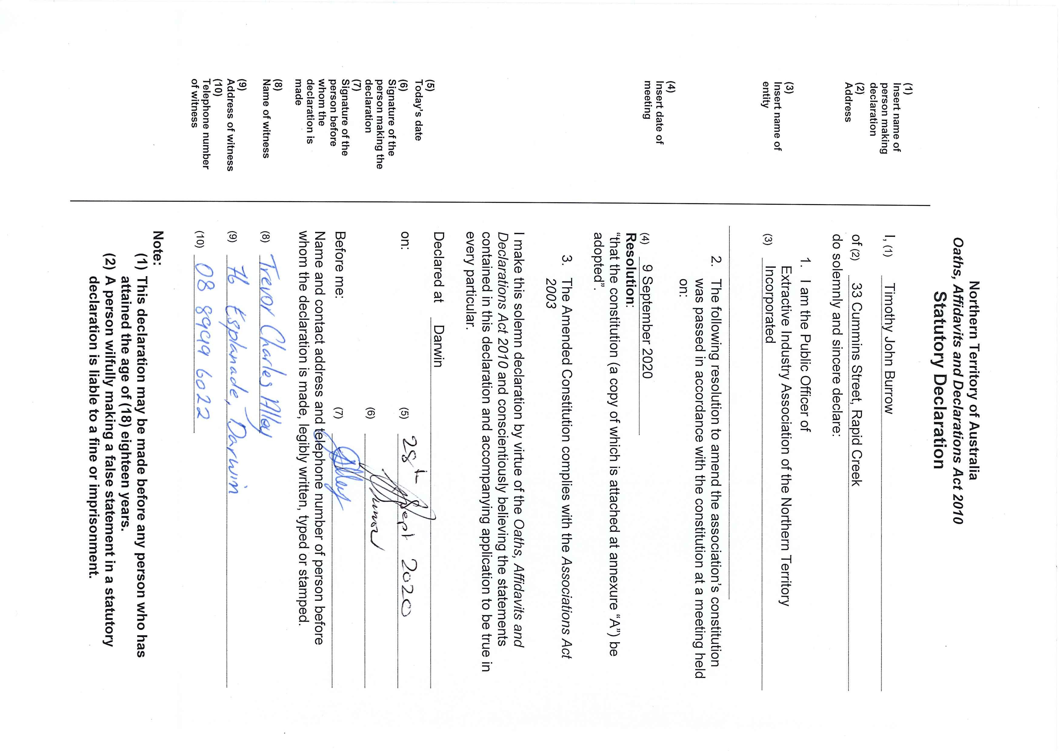
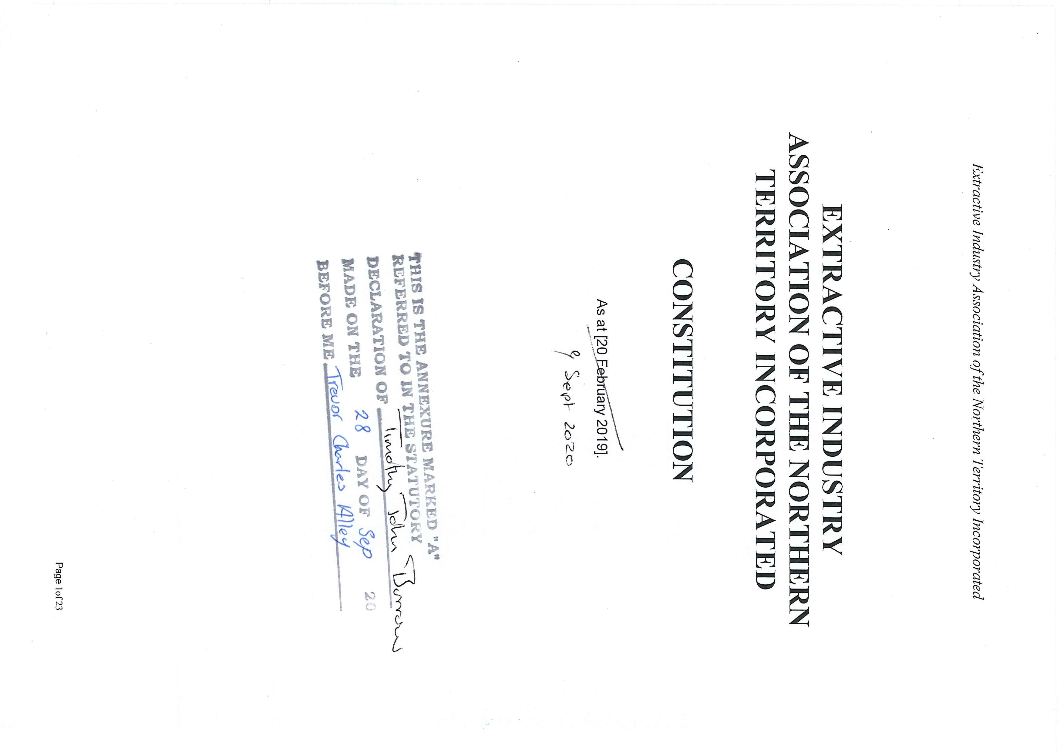

PART 1 – PRELIMINARY

1. Name
The name of the incorporated association ("the Association") is Extractive Industry Association of the Northern Territory Incorporated.

2. Objects and purposes
The objects and purposes of the Association are as follows:
- Represent and promote the Extractive Industry and to represent the members in all or any matters which affects them generally, or which affects and improves that status of the Extractive Industry by research, investigation, advertising and such other lawful means, as the Association shall consider advisable.
- Acquire, preserve and disseminate business and trade information likely to benefit the Extractive Industry or those engaged in or connected with it.
- Encourage and promote honourable and ethical relations between:
  - members themselves;
  - members and persons carrying on business directly or indirectly associated with the Extractive Industry who are not members; and
  - members and government departments with all of the general public.
- Foster sound and modern practice among its members and encourage the retention of high standards of conduct.
- Assist, advise, confer and co-operate with public authorities or other bodies or persons in regard to all matters affecting the Extractive Industry.
- Promote public awareness of the Extractive Industry’s role in society and to ensure educators, students, community groups and the general public have a balanced and informed understanding of the Extractive Industry.
- Do all such things as may be incidental or conducive to the attainment of the above objects or any of them as may be deemed necessary or expedient in the best interests of the Association.
3. Minimum number of members
The Association must have at least five (5) members.

4. Definitions
In this Constitution, unless the contrary intention appears –
"Act" means the Associations Act and regulations made under that Act;
“Affiliate Member” means a person who is:
- a related body corporate (as that term is defined by the
Corporations Act 2001 (Cth)) of a Full Member;
- an immediate family member of a Full Member;
- a spouse or de facto partner of a Full Member; or
- an immediate family member, spouse or de facto partner of a director of a Full Member; and
is, in the opinion of the Committee, integral to the Full Member’s operation as an Extractive Miner and is appointed as an Affiliate Member pursuant to this Constitution;
“Associate Member” means such members who are not Extractive
Miners but whose expertise or interest may benefit the Association;
"Committee" means the Management Committee of the Association;
“committee member” means a member of the Committee;
“Constitution” means this constitution;
“Exceptional Service” includes, but is not limited to, a member who has rendered continuing and outstanding service to the Association;
“Extractive Industry” means the industry relating to the exploration, location, mining, processing and transport of Extractive Minerals;
“Extractive Miner” means a person who holds mineral title, as that term is defined in the Mineral Titles Act, which authorizes the exploration or mining of Extractive Minerals;
“Extractive Minerals” means “extractive minerals” as that term is defined in the Mineral Titles Act , and such other minerals and commodities that may be endorsed by the Association at an Annual General Meeting as being extractive minerals;
"Financial Institution" means an authorised deposit-taking institution within the meaning of section 5 of the Banking Act 1959 (Cth) of the Commonwealth;
“Full Member” means such members who are Extractive Miners; "general meeting" means a general meeting of members convened in accordance with clause 46;
“Life Member” means a member of the Association who has been appointed a Life Member pursuant to this Constitution;
“Management Committee” means the group of members specified in clause 26;
“member” means a member of the Association;
"Register of Members" means the register of the Association's members established and maintained under section 34 of the Act;
"special resolution" means a resolution notice of which is given under clause 47 and passed in accordance with section 37 of the Act.

PART 2 – CONSTITUTION AND POWERS OF ASSOCIATION

5. Powers of Association
- For achieving its objects and purposes, the Association has the powers conferred by sections 11 and 13 of the Act.
- Subject to the Act, the Association may do all things necessary or convenient for carrying out its objects or purposes, and in particular, may:
  - acquire, hold and dispose of real or personal property;
  - open and operate accounts with Financial Institutions;
  - invest its money in any security in which trust monies may lawfully be invested;
  - raise and borrow money on the terms and in the manner it
considers appropriate;
  - secure the repayment of money raised or borrowed, or the
payment of a debt or liability;
  - appoint agents to transact business on its behalf; and
  - enter into any other contract it considers necessary or desirable.

6. Effect of Constitution
This Constitution binds every member and the Association to the same extent as if every member and the Association had signed and sealed this Constitution and agreed to be bound by it.

7. Inconsistency between Constitution and Act
If there is any inconsistency between this Constitution and the Act, the Act prevails.

8. Altering the Constitution
- The Association may alter this Constitution by special resolution but not otherwise.
- If the Constitution is altered, the public officer must ensure compliance with section 23 of the Act.

PART 3 – MEMBERS

Division 1 – Membership

9. Classes of Membership
- Application for membership of the Association may be made for the classes of either:
  - Full Member; (b) Associate Member; or (c) Affiliate Member.
- A member (being either a Full Member or Associate Member) may be awarded Life Membership by the Committee if:
  - that member has been nominated in writing to the Committee by any other member;
  - the nominee has at least ten (10) years service as a member of the Association;
  - in the opinion of the Committee the nominee has rendered Exceptional Service to the Association;
  - in the opinion of the Committee the nominee is of exemplary moral and ethical standing; and
  - all members of the Committee vote in favour of awarding the nominee Life Membership at a meeting of the Committee.

10. Application for membership
- Subject to clause 10(2), to apply to become a member of the Association a person must submit a written application for membership to the Committee in a form approved by the Committee.
- To apply to become an Affiliate Member of the Association the Full Member and the person must submit a written application for membership to the Committee in the form approved by the Committee.

11. Approval of Committee
- The Committee must consider any application made under clause 10 at the next available committee meeting and must accept or reject the application at that meeting or the next.
- If an application is rejected, the applicant may appeal against the decision by giving notice to the Secretary within 14 days after being advised of the rejection.
- If an applicant gives notice of an appeal against the rejection of his or her application, the Committee must reconsider the application at the next committee meeting after receipt of the notice of appeal.
- If after reconsidering an application the Committee reaffirms its decision to reject the application, the decision is final.

12. Joining fee
- If an application for membership is approved by the Committee, the applicant becomes a member on payment of the joining fee.
- The joining fee is the amount determined from time to time by resolution at a general meeting.

13. Annual membership fees
- The annual membership fee is the amount determined from time to time by resolution at a general meeting.
- Each member must pay the annual membership fee to the Treasurer by the first day of each financial year or another date determined by the Committee from time to time.
- Life Members are not subject to an annual membership fee.
- A member whose annual membership fee is not paid within one (1) month after of the date prescribed by this clause ceases to be a member unless the Committee determines otherwise.

Division 2 – Rights of members

14. General
- Subject to clause 15(2), a member may exercise the rights of membership when his or her name is entered in the Register of Members.
- A right of membership of the Association –
  - is not capable of being transferred or transmitted to another person; and
  - terminates on the cessation of membership whether by death, resignation or otherwise.

15. Voting
- Subject to subclause (2) and clauses 21 and 22, each member has one vote at general meetings of the Association.
- A member is not eligible to vote until 10 working days after his or her application has been accepted.

16. Notice of meetings and special resolutions
The Secretary must give all members notice of general meetings and special resolutions in the manner and time prescribed by this
Constitution.

17. Access to information on Association
The following must be available for inspection by members:
- a copy of this Constitution;
- minutes of general meetings;
- annual reports and annual financial reports.

18. Raising grievances and complaints
- A member may raise a grievance or complaint about a committee member, the Committee or another member of the Association.
- The grievance or complaint must be dealt with by the procedures set out in Part 8.

19. Associate Members
An Associate Member must not vote except in accordance with clause 26 or on matters of a social nature but may have other rights as determined by the Committee or by resolution at a general meeting.

19A. Affiliate Members
An Affiliate Member is not entitled to vote but may have other rights as determined by the Committee or by resolution at a general meeting.

20. Life Members
A Life Member has all the rights of a Full Member but is not subject to annual membership fees.

Division 3 – Termination, death, suspension and expulsion

21. Termination of membership
Membership of the Association may be terminated by –
- a notice of resignation addressed and posted to the Association or given personally to the Secretary or another committee member;
- non-payment of the annual membership fee within the time
allowed under clause 13(4); or
- expulsion in accordance with this Division.

22. Death of member or whereabouts unknown
If a member dies or the whereabouts of a member are unknown, the Committee must cancel the member's membership.

23. Suspension or expulsion of members
- If the Committee considers that a member should be suspended or expelled because his or her conduct is detrimental to the interests of the Association, the Committee must give notice of the proposed suspension or expulsion to the member.
- The notice must –
  - be in writing and include –
    - the time, date and place of the committee meeting at which the question of that suspension or expulsion will be decided; and
    - the particulars of the conduct; and
  - be given to the member not less than 30 days before the date of the committee meeting referred to in paragraph (a)(i).
- At the meeting, the Committee must afford the member a reasonable opportunity to be heard or to make representations in writing.
- The Committee may suspend or expel or decline to suspend or expel the member from the Association and must give written notice of the decision and the reason for it to the member.
- Subject to clause 24, the decision to suspend or expel a member takes effect 14 days after the day on which notice of the decision is given to the member.

24. Appeals against suspension or expulsion
- A member who is suspended or expelled under clause 23 may appeal against that suspension or expulsion by giving notice to the Secretary within 14 days after receipt of the Committee's decision.
- The appeal must be considered at a general meeting of the Association and the member must be afforded a reasonable opportunity to be heard at the meeting or to make representations in writing prior to the meeting for circulation at the meeting.
- The members present at the general meeting must, by resolution, either confirm or set aside the decision of the Committee to suspend or expel the member.
- The member is not suspended or does not cease to be a member until the decision of the Committee to suspend or expel him or her is confirmed by a resolution of the members. 24A. Effect of termination of Affiliate Members
- If the membership of a Full Member:
  - is terminated in accordance with the processes of this Division then the membership of the Affiliate Member (if any) recorded in the Register of Members as being related to the Full Member is deemed to be terminated on and from the date that the termination of Full Member’s membership takes effect; or
  - is suspended in accordance with the processes of this Division then the membership of the Affiliate Member (if any) recorded in the Register of Members as being related to the Full Member is deemed to be suspended on and from the date that the suspension of Full Member’s membership takes effect.
- An Affiliate Member’s rights of membership are inextricably linked to those of the Full Member whom lodged the membership application for an affiliate membership in accordance with clause 10(2) and, for the avoidance of doubt, an Affiliate Member has no rights of membership if the membership of the Full Member recorded in the Register of Members as being related to the Full Member is terminated or suspended in accordance with this Division.
- If the Committee commences proceedings against a Full Member under this Division then the Committee must afford the same procedural rights under clause 23 to the Affiliate Member (if any) recorded in the Register

of Members as being related to the Full Member including but not limited to:
  - the right to receive written notice under clause 23(1) and clause 23(4); and
  - the right to be heard or to make representations in writing in accordance with clause 23(3).

PART 4 – MANAGEMENT COMMITTEE

Division 1 – General

25. Role and powers
- The business of the Association must be managed by or under the direction of a Management Committee.
- The Committee may exercise all the powers of the Association except those matters that the Act or this Constitution requires the Association to determine through a general meeting of members.
- The Committee may appoint and remove staff.
- The Committee may establish one or more subcommittees consisting of the members of the Association the Committee considers appropriate.

26. Composition of Committee
- The Management Committee consists of –
  - a Chairperson;
  - a Vice-Chairperson;
  - a Secretary;
  - a Treasurer; and
  - six (6) ordinary committee members (of which no more than two (2) may be members who are not Full Members and who possess expertise in a field which is considered by the membership to be of particular benefit to the Committee).
- All committee members, regardless of the class of membership held, are eligible to vote on all matters considered by the Committee unless disqualified by the provisions of clause 45.
- Unless elected directly as a separate office holder, the Committee must appoint one committee member to be the Association's public officer.

27. Delegation
- The Committee may delegate to a subcommittee or staff any of its powers and functions other than – (a) this power of delegation; or
(b) a duty imposed on the Committee by the Act or any other law.
- The delegation must be in writing and may be subject to the conditions and limitations the Committee considers appropriate.
- The Committee may, in writing, revoke wholly or in part the delegation.

Division 2 – Tenure of office

28. Eligibility of committee members
- A committee member must be a member who is 18 years or over.
- A committee member must be either:
  - a member of the Association; or
  - an employee of a member of the Association.
- A committee member must be a Full Member except for an ordinary committee member under clause 26(e).
- Notwithstanding clause 26(e) a committee member must not be an Affiliate Member.
- Committee members must be elected to the Committee at an annual general meeting or appointed under clause 37.

28A. Alternate committee members
- Any of the six (6) ordinary committee members may, in nominating for election to the Committee, also nominate an individual to act as an alternate on the Committee.
- An alternate:
  - must be an employee of the same member of the Association as the ordinary committee member;
  - may attend any meeting that the ordinary committee member is entitled to attend and receive any information that the ordinary committee member is entitled to receive;
  - does not count as an attendee for the purposes of quorum unless the relevant ordinary committee member is not present;
  - has all the same obligations as the ordinary committee member;
  - may exercise any rights of the ordinary member, except an alternate may only exercise such rights if the ordinary member has not exercised those same rights.
- To clarify:
  - If an ordinary committee member has nominated an alternate in accordance with this Constitution, then upon the election of that ordinary committee member the alternate is also elected .
  - If the office of the ordinary committee member becomes vacant or is otherwise removed in accordance with this Constitution then the position of the alternate also becomes vacant

29. Nominations for election to committee
- A member is not eligible for election to the Committee unless the Secretary receives a written nomination for that member by another member not less than 7 days before the date of the next annual general meeting.
- The nomination must be signed by – (a) the nominator and a seconder;
  - the nominee to signify his or her willingness to stand for election;
  - if applicable, the proposed alternate nominee to signify his or her willingness to stand for election.
- A person who is eligible for election or re-election under this clause may –
  - propose or second himself or herself for election or re-election; and
  - vote for himself or herself.

30. Retirement of committee members
- A committee member holds office until the next annual general meeting unless the member vacates the office under clause 33 or is removed under clause 34.
- Subject to subclause (3), at an annual general meeting the office of each committee member becomes vacant and elections for a new Committee must be held.
- The outgoing Chairperson of the Committee must preside at the annual general meeting until a new member is elected as Chairperson.
- Members may serve consecutive terms on the Committee.

31. Election by default
- If the number of persons nominated for election to the Committee under clause 29 does not exceed the number of vacancies to be filled, the Chairperson must declare the persons to be duly elected as members of the Committee at the annual general meeting.
- If vacancies remain on the Committee after the declaration under subclause (1), additional nominations of committee members may be accepted from the floor of the annual general meeting.
- If the nominations from the floor do not exceed the number of remaining vacancies, the Chairperson must declare those persons to be duly elected as members of the Committee.
- If the nominations from the floor are less than the number of remaining vacancies, the unfilled vacancies are taken to be casual vacancies and must be filled by the new Committee in accordance with clause 33.

32. Election by ballot
- If the number of nominations exceeds the number of vacancies on the Committee, ballots for those positions must be conducted.
- The ballot must be conducted in a manner determined from time to time by resolution at a general meeting.
- The members chosen by ballot must be declared by the Chairperson to be duly elected as members of the Committee.

33. Vacating office
The office of a committee member becomes vacant if –
- the member –
  - is disqualified from being a committee member under section 30 or 40 of the Act;
  - resigns by giving written notice to the Committee;
  - dies or is rendered permanently incapable of performing the duties of office by mental or physical ill-health;
  - ceases to be a resident of the Territory; or
  - ceases to be either:
    - a member of the Association; or
    - an employee of a member of the Association,
- the member is absent from more than – (a) 3 consecutive committee meetings; or
(b) 3 committee meetings in the same financial year without tendering an apology to the Chairperson;
of which meetings the member received notice and the Committee has resolved to declare the office vacant; or
- in any of the circumstances provided for by the Schedule.

34. Removal of committee member
- The Association, through a special general meeting of members, may remove any committee member before the member's term of office ends.
- If a vacancy arises through removal under subclause (1), an election must be held to fill the vacancy.

35. Filling casual vacancy on Committee
- If a vacancy remains on the Committee after the application of clause 31 or if the office of a committee member becomes vacant under clause 33, the Committee may appoint any member of the Association to fill that vacancy.
- However, if the office of public officer becomes vacant, a person must be appointed under section 27(6) of the Act to fill the vacancy.

Division 3 – Duties of committee members

36. Collective responsibility of Committee
- As soon as practicable after being elected to the Committee, each committee member must become familiar with the Act and regulations made under the Act.
- The Committee is collectively responsible for ensuring the Association complies with the Act and regulations made under the Act.

37. Chairperson and Vice-Chairperson
- Subject to subclauses (2) and (3), the Chairperson must preside at all general meetings and committee meetings.
- If the Chairperson is absent from a meeting, the Vice-Chairperson must preside at the meeting.
- If the Chairperson and the Vice-Chairperson are both absent, the presiding member for that meeting must be –
  - a member elected by the other members present if it is a general meeting; or
  - a committee member elected by the other committee members present if it is a committee meeting.

38. Secretary
The Secretary must –
- coordinate the correspondence of the Association;
- ensure minutes of all proceedings of general meetings and of committee meetings are kept in accordance with section 38 of the Act;
- maintain the Register of Members in accordance with section 34 of the Act and ensure that the Register of Members identifies the relationship between an Affiliate Member and a Full Member (if any);
- unless the members resolve otherwise at a general meeting – have custody of all books, documents, records and registers of the Association, other than those required by clause 39(5) to be in the custody of the Treasurer; and
- perform any other duties imposed by this Constitution on the Secretary.

39. Treasurer
- The Treasurer must –
  - receive all moneys paid to or received by the Association and issue receipts for those moneys in the name of the Association;
  - pay all moneys received into the account of the Association within 5 working days after receipt;
  - make any payments authorised by the Committee or by a general meeting of the Association from the Association's funds; and
  - ensure cheques are signed by him or her and at least one other committee member, or by any 2 other committee members authorised by the Committee (not including an alternate).
- The Treasurer must ensure the accounting records of the Association are kept in accordance with section 41 of the Act.
- The Treasurer must coordinate the preparation of the Association's annual statement of accounts.
- If directed to do so by the Chairperson, the Treasurer must submit to the Committee a report, balance sheet or financial statement in accordance with that direction.
- The Treasurer has custody of all securities, books and documents of a financial nature and accounting records of the Association unless the members resolve otherwise at a general meeting.
- The Treasurer must perform any other duties imposed by this
Constitution on the Treasurer.

40. Public officer
- The public officer must ensure that documents are filed with the Commissioner of Consumer Affairs in accordance with sections 23, 28 and 45 of the Act.
- The public officer must keep a current copy of the Constitution of the Association.

PART 5 – MEETINGS OF MANAGEMENT COMMITTEE

41. Frequency and calling of meetings
- The Committee must meet together for the conduct of business not less than 4 times in each financial year unless otherwise provided in the Schedule.
- The Chairperson, or at least half the committee members, may at any time convene a special meeting of the Committee.
- A special meeting may be convened to deal with an appeal under clause 23.

42. Voting and decision making
- Each committee member present at the meeting has a deliberative vote.
- A question arising at a committee meeting must be decided by a majority of votes.
- If there is no majority, the person presiding at the meeting has a casting vote in addition to a deliberative vote.

43. Quorum
For a committee meeting, three (3) of the committee members constitutes a quorum.

44. Procedure and order of business
- The procedure to be followed at a committee meeting must be determined from time to time by the Committee.
- The order of business may be determined by the members present at the meeting.
- Only the business for which the meeting is convened may be considered at a special meeting.

45. Disclosure of interest
- A committee member who has a direct or indirect pecuniary interest in a contract, or proposed contract, with the Association must disclose the nature and extent of the interest to the Committee in accordance with section 31 of the Act.
- The Secretary must record the disclosure in the minutes of the meeting.
- The Chairperson must ensure a committee member who has a direct or indirect pecuniary interest in a contract, or proposed contract, complies with section 32 of the Act.

PART 6 – GENERAL MEETINGS

46. Convening general meetings
- The Association must hold its first annual general meeting within 18 months after its incorporation.
- The Association must hold all subsequent annual general meetings within 5 months after the end of the Association's financial year.
- The Committee –
  - may at any time convene a special general meeting;
  - must, within 30 days after the Secretary receives a notice under clause 24(1), convene a special general meeting to deal with the appeal to which the notice relates; and
  - must, within 30 days after it receives a request under clause 47(1), convene a special general meeting for the purpose specified in that request.

47. Special general meetings
- Half the number of members constituting a quorum for a general meeting may make a written request to the Committee for a special general meeting unless otherwise provided in the Schedule.
- The request must –
  - state the purpose of the special general meeting; and (b) be signed by the members making the request.
- If the Committee fails to convene a special general meeting within the time allowed –
  - for clause 46(3)(b) – the appeal against the decision of the Committee is upheld; and
  - for clause 46(3)(c) – the members who made the request may convene a special general meeting as if they were the Committee.
- If a special general meeting is convened under subclause (3)(b), the Association must meet any reasonable expenses of convening and holding the special general meeting.
- The Secretary must give to all members not less than 21 days notice of a special general meeting.
- The notice must specify –
  - when and where the meeting is to be held; and
  - the particulars of and the order in which business is to be transacted.

48. Annual general meeting
- The Secretary must give to all members not less than 30 days notice of an annual general meeting unless otherwise provided in the Schedule.
- The notice must specify –
  - when and where the meeting is to be held; and
  - the particulars of and the order in which business is to be transacted.
- The order of business for each annual general meeting is as follows:
  - first – the consideration of the accounts and reports of the Committee;
  - second – the election of new committee members;
  - third – any other business requiring consideration by the Association at the meeting.

49. Special resolutions
- A special resolution may be moved at any general meeting of the Association.
- The Secretary must give all members not less than 21 days notice of the meeting at which a special resolution is to be proposed unless otherwise provided in the Schedule.
- The notice must include the resolution to be proposed and the intention to propose the resolution as a special resolution.

50. Notice of meetings
- The Secretary must give a notice under this Part by –
  - serving it on a member personally; or
  - sending it by post to a member at the address of the member appearing in the Register of Members; or
  - sending it by electronic means to a member at the email address of the member appearing in the Register of Members.
- If a notice is sent by post under subclause (1)(b), sending of the notice is taken to have been properly effected if the notice is addressed and posted to the member by ordinary prepaid mail.
- If a notice is sent by email under subclause (1)(c), sending of the notice is taken to have been properly effected if no notice of inability to deliver to the addressee is received at the time of sending.

51. Quorum at general meetings
At a general meeting, one third (1/3) of the members present in person or by proxy constitutes a quorum.

52. Lack of quorum
- If within 30 minutes after the time specified in the notice for the holding of a general meeting a quorum is not present –
  - for an annual general meeting or special general meeting convened under clause 46(3)(a) – the meeting stands adjourned to the same time on the same day in the following week and to the same place;
  - for a meeting convened under clause 46(3)(b) – the members who are present in person or by proxy may proceed with hearing the appeal for which the meeting is convened; or
  - for a meeting convened under clause 46(3)(c) – the meeting lapses.
- If within 30 minutes after the time appointed by subclause (1)(a) for the resumption of an adjourned general meeting a quorum is not present, the members who are present in person or by proxy may proceed with the business of that general meeting as if a quorum were present.
- The Chairperson may, with the consent of a general meeting at which a quorum is present, and must, if directed by the members at the meeting, adjourn that general meeting from time to time and from place to place.
- There must not be transacted at an adjourned general meeting any business other than business left unfinished or on the agenda at the time when the general meeting was adjourned.
- If a general meeting is adjourned for a period of 30 days or more, the Secretary must give notice of the adjourned general meeting as if that general meeting were a fresh general meeting.

53. Voting
- Subject to clauses 15(2), 19, 19A and 20, each member present in person or by proxy at a general meeting is entitled to a deliberative vote.
- At a general meeting –
  - an ordinary resolution put to the vote is decided by a majority of votes made in person or by proxy; and
  - a special resolution put to the vote is passed if three-quarters of the members who are present in person or by proxy vote in favour of the resolution.
- A poll may be demanded by the Chairperson or by 3 or more members present in person or by proxy.
- If demanded, a poll must be taken immediately and in the manner the Chairperson directs.

54. Proxies
- Subject to sub clause 2, a member may appoint in writing another member to be the proxy of the appointing member to attend and vote on behalf of the appointing member at any general meeting.
- A member is limited to holding a single proxy vote at any meeting of the Association.
- In the event a member holds multiple proxies, only the first cast proxy vote at a meeting will counted and all other proxy vote cast will be deemed invalid.

PART 7 – FINANCIAL MANAGEMENT

55. Financial year
The financial year of the Association is the twelve month period ending on 30 April.

56. Funds and accounts
- The Association must open an account with a Financial Institution from which all expenditure of the Association is made and into which all of the Association's revenue is deposited.
- Subject to any restrictions imposed by the Association at a general meeting, the Committee may approve expenditure on behalf of the Association within the limits of the budget.
- All cheques, drafts, bills of exchange, promissory notes and other negotiable instruments must be signed by any 2 of the following:
  - an employee of the Association nominated by the Committee from time to time;
  - a Life Member;
  - a committee member (but does not include an alternate).
- All funds of the Association must be deposited into the financial account of the Association no later than 5 working days after receipt or as soon as practicable after that day.
- With the approval of the Committee, the Treasurer may maintain a cash float provided that all money paid from or paid into the float is accurately recorded at the time of the transaction.

57. Accounts and audits
The responsibility of the Committee under clause 36(2) for ensuring compliance with the Act includes meeting the requirements of Part 5 of the Act and regulations made for that Part relating to –
- the keeping of accounting records;
- the preparation and presentation of the Association's annual statement of accounts; and
- the auditing of the Association's accounts.

PART 8 – GRIEVANCE AND DISPUTES

58. Grievance and disputes procedures
- This clause applies to disputes between – (a) a member and another member; or (b) a member and the Committee.
- Within 14 days after the dispute comes to the attention of the parties to the dispute, they must meet and discuss the matter in dispute, and, if possible, resolve the dispute.
- If the parties are unable to resolve the dispute at the meeting, or if a party fails to attend that meeting, then the parties must, within 10 days after the meeting, hold another meeting in the presence of a mediator.
- The mediator must be –
  - a person chosen by agreement between the parties; or
  - in the absence of agreement –
    - for a dispute between a member and another member – a person appointed by the Committee; or
    - for a dispute between a member and the Committee – a person who is a mediator appointed or employed by the department administering the Act.
- A member of the Association can be a mediator.
- The mediator cannot be a party to the dispute.
- The parties to the dispute must, in good faith, attempt to settle the dispute by mediation.
- The mediator, in conducting the mediation, must –
  - give the parties to the mediation process every opportunity to be heard;
  - allow due consideration by all parties of any written statement submitted by any party; and
  - ensure natural justice is accorded to the parties to the dispute throughout the mediation process.
- The mediator must not determine the dispute.
- If the mediation process does not result in the dispute being resolved, the parties may seek to resolve the dispute in accordance with the Act or otherwise at law.

PART 9 – MISCELLANEOUS

59. Common seal
- The common seal of the Association must not be used without the express authority of the Committee and every use of that common seal must be recorded by the Secretary.
- The affixing of the common seal of the Association must be witnessed by any 2 of the following:
  - the Chairperson;
  - the Secretary;
  - the Treasurer.
- The common seal of the Association must be kept in the custody of the Secretary or another person the Committee from time to time decides.

60. Distribution of surplus assets on winding up
- If on the winding up or dissolution of the Association, and after satisfaction of all its debts and liabilities, there remains any assets, the assets must not be distributed to the members or former members.
- The surplus assets must be given or transferred to another association incorporated under the Act that –
  - has similar objects or purposes;
  - is not carried on for profit or gain to its individual members; and (c) is determined by resolution of the members.

